H.T No
Regulations:
A17

Sreenidhi Institute of Science and Technology
(An Autonomous Institution)
Code No: 6AC07 Date: 12-Mar-2021 (AN)

B.Tech II-Year II- Semester External Examination, March/April - 2021 (Supplementary)
CONTROL SYSTEMS (EEE)

Time: 3 Hours Max.Marks:75

Note: a) No additional answer sheets will be provided.
b) All sub-parts of a question must be answered at one place only, otherwise it will not be valued.
c) Missing data can be assumed suitably.

ANSWER ANY 5 OUT OF 8 QUESTIONS. EACH QUESTION CARRIES 15 MARKS.

Bloom's Cognitive Levels of Learning (BCLL)

Remember | L1 | Apply | L3 | Evaluate | L5
Understand | L2 | Analyze | L4 | Create | L6

 |  |  | BCLL | CO(s) | Marks
1. | a) | Obtain the transfer function relating C(s) and R(s) for the block diagram shown in below figure.  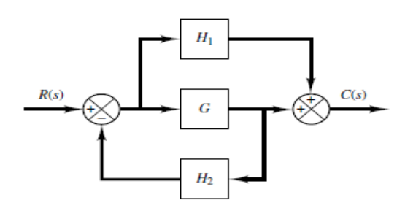 | L3 | CO1 | [8M]
 | b) | Explain working of Synchros. | L2 | CO1 | [7M]
2. | a) | Define the following terms.  i) Delay time ii) Rise time  iii) Peak time iv) Peak overshoot  v) settling time vi) steady-state error | L1 | CO2 | [8M]
 | b) | A second order system has a damping ratio of 0.7 and its natural frequency of oscillation is 12 radians per second. Determine the damped frequency of oscillation, rise time, peak time, peak overshoot and settling time. | L3 | CO2 | [7M]
3. | a) | Determine the stability of the system represented by s⁶+2s⁵+s⁴+2s³+3s²+4s+5 using Routh stability criterion. | L3 | CO3 | [8M]
 | b) | A unity feedback control system is characterized by the open loop transfer function . Calculate the range of values of K for the system to be stable and what is marginal value of K for stability. | L4 | CO3 | [7M]
4. |  | Sketch the Bode plot for the following transfer function and determine the system gain cross-over frequency, phase cross over frequency gain margin and phase margin. | L4 | CO4 | [15M]
5. | a) | Derive expression for the transfer function of a Lead compensator. | L3 | CO5 | [8M]
 | b) | Explain PID controller. | L2 | CO5 | [7M]
6. | a) | Obtain state space representation of following system?  +6+11+6y=6u | L2 | CO6 | [8M]
 | b) | Define controllability and observability. | L1 | CO6 | [7M]
7. | a) | Why negative feedback is preferred in control systems. | L2 | CO1 | [3M]
 | b) | What is the location of poles for different types of damped systems? | L1 | CO2 | [3M]
 | c) | Explain procedure steps to draw root locus. | L2 | CO3 | [9M]
8. | a) | What are the advantages of bode plot? | L2 | CO4 | [6M]
 | b) | Sketch the polar plots of transfer function. | L3 | CO5 | [6M]
 | c) | What is the significance of state transition matrix? | L1 | CO6 | [3M]

-- 00 -- 00 –

